Screenshot 1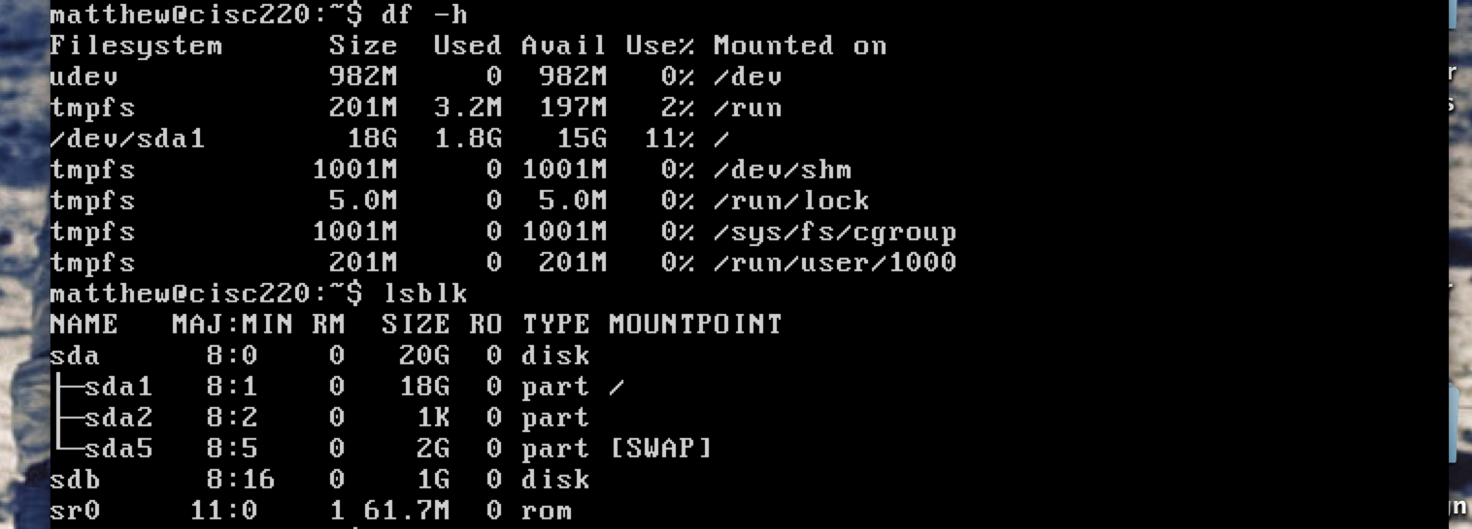

Question 1: lsblk

Screenshot 2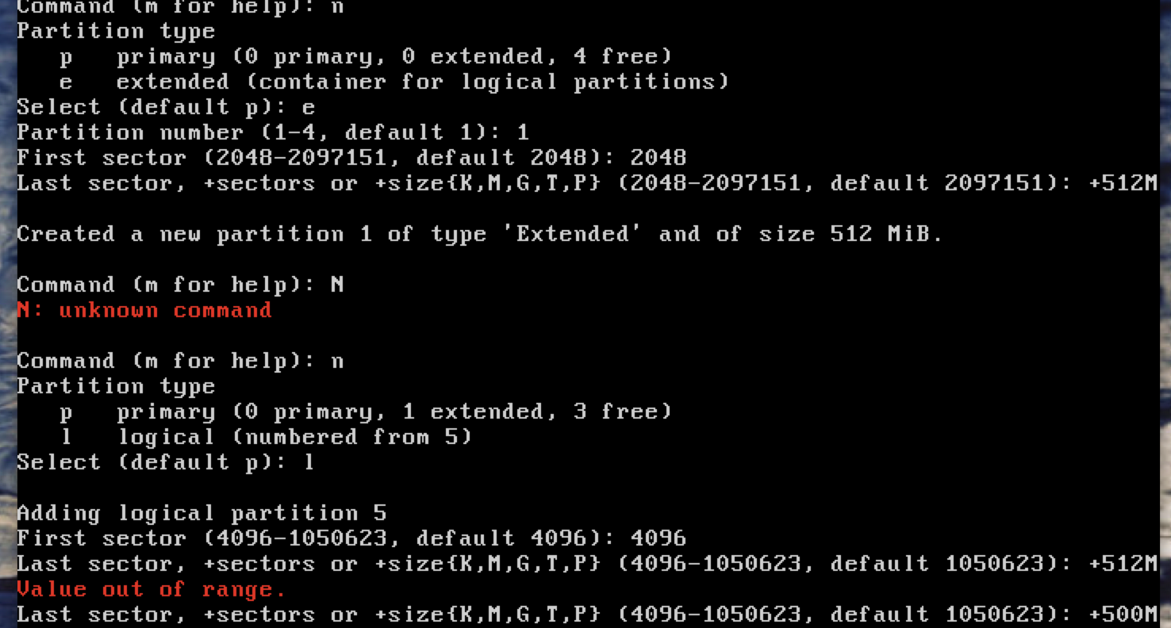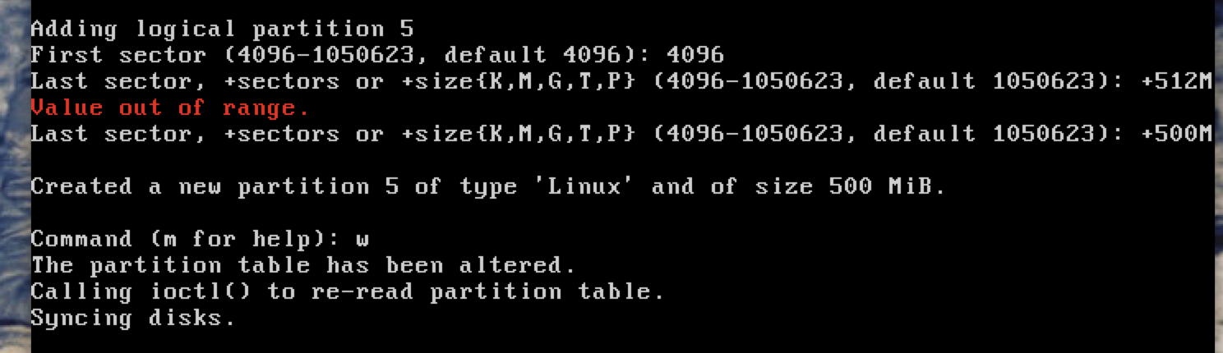

Screenshot 3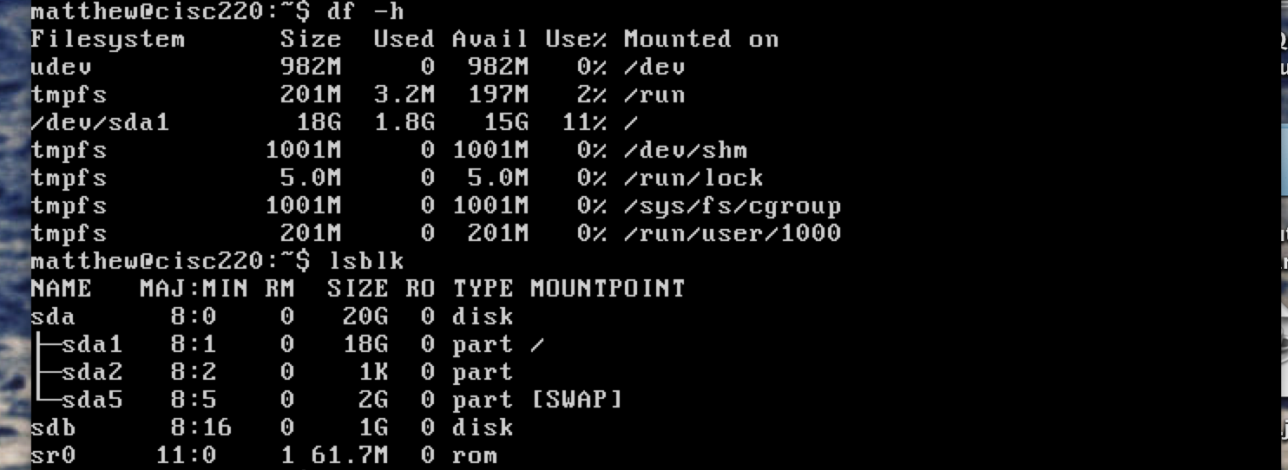

Question 2: lsblk

Screenshot 4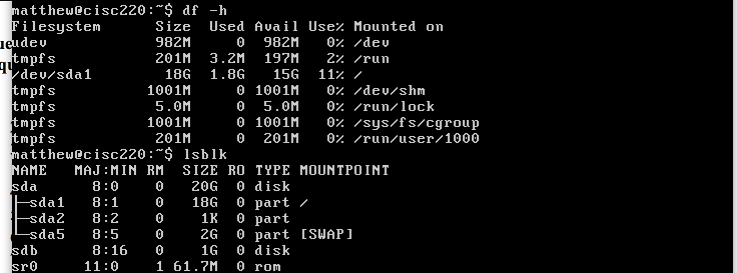

Question 3: lsblk